**16.2**

1. Model A is better at explaining the time series because its RMSE is lower for the training set, so we know that model A is closer to the real data than model B
2. Model B is better to forecast the time series because its RMSE is lower for the validation set, so we know that model B is closer to the real data than model B

**16.3**

1. Gráfico, Histograma

   Descripción generada automáticamente
2. Level: Because we have the data for each observation

Trend: Because there is an increasing and interrupted trend in the plot.

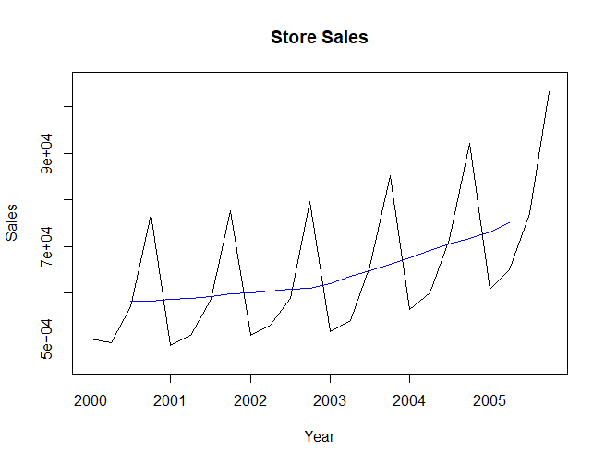

We can even say that the trend is exponential because if we calculate the sales log and display the trend, we can also see the trend.

Seasonality: Because there are regular oscillations in the same month of each year. We can see that the sales drop always in the first period.

Noise: There’s noise in the series because there are some changes in the trend that we can’t explain

**16.4**

1. Gráfico, Gráfico de líneas

   Descripción generada automáticamente
2. Level: Because we have the data for each observation

Trend: Because there is an increasing trend in the plot, except between the 1888-1889 period that the series has a decreasing trend.

Seasonality: Because there are regular oscillations in the same month of each year. We can see that the shipments drop always in the 3rd period, except in 1988.

Noise: There’s noise in the series because there are some changes in the trend that we can’t explain

**16.5**

1. Gráfico, Gráfico de líneas

   Descripción generada automáticamente
2. Level: Because we have the data for each observation.

Trend: Because there is a decreasing trend in the plot between 1966 and 1988 and then the trend changes and it starts decreasing.

Noise: There’s noise in the series because there are some changes in the trend that we can’t explain

**16.6**

1. Gráfico, Histograma

   Descripción generada automáticamente
2. Gráfico, Gráfico de líneas, Histograma

   Descripción generada automáticamente
3. The second plot has less noise because the trend approximates the actual data much better, that’s because the data increase exponentially so we have to take the log of the data.

1. The data is partitioned because we first need to build our model in the training set, then we have to validate the model in the validation set.